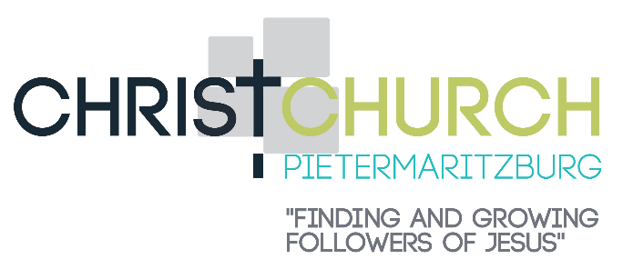

Friday 19

Pray for Luis Esteves as he serves both in the church life as well as at KMBC where he lectures to equip students to pastor churches in Africa.

Saturday 20

Thank God for the privilege of prayer! Pray that our church would become known as a praying church; one that makes prayer a priority and puts it into practice.

Sunday 21

Thank God for being a good Creator of everything everywhere to reflect His glory. When we look at the world around us, may we be reminded of God’s love and power. Thank Him for the privilege of belonging to Him.

Monday 22

Ask God to help us remember that there is a mission field on our own doorstep. Pray that God will fill you with boldness to be witnesses for Him. and we will be given many opportunities to share the gospel with friends, family, work colleagues and neighbours.

Tuesday 23

Remember Jinx and Dawn Reyneke as they await for the finalization and approval of their investment visas to enter Namibia as well as for the sale of their house to invest in their new missionary venture (BAM [business as mission]).

Wednesday 24

Pray for your own walk with the Lord. Pray for diligence in regular Bible reading and prayer. Pray for godliness in your relationships at home and at the office so that others will see Jesus reflected in your life.

Thursday 25

Thank God for our Caring Listeners. Pray that God will equip them to assist those in need.

Friday 26

Thank God for Men for the Master. Pray that these men will grow in spiritual maturity through God’s word, and that more men from the church will join on Friday mornings.

Saturday 27

Pray for Wayne and Anne Barkhuizen. Thank God for the way Wayne leads and guides us as the church family.

Sunday 28

Thank God for Sundays and the privilege to hear His Word read and preached. Pray that many will hear and listen to obey and apply it to our lives.

Monday 29

Pray for our seniors who meet on Monday mornings that they will be encouraged as they meet around God’s word, for good health and that those who are lonely will be comforted.

Tuesday 30

Thank God for Heidi Hill who serves our church family in so many practical ways behind the scenes in her housekeeping responsibilities.

Wednesday 31

Thank God for the encouragement and assurance of His word knowing that He will care for us as we persevere in the faith. Ask that He will give you a faith that endures in a world that is so quick to give up. Pray also for the disciplines of prayer, love and care to be evident in our lives as we look to His coming.

Prayer Diary
AUGUST 2022

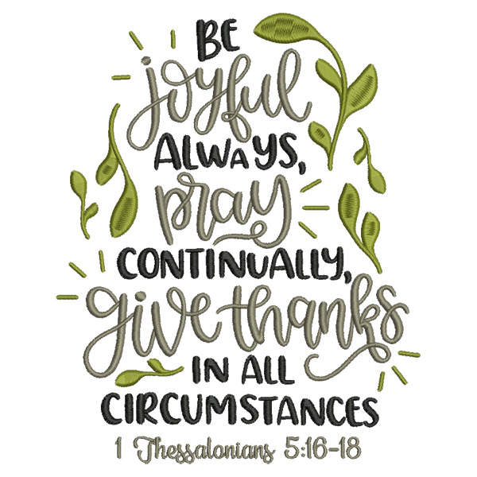

Monday 1

The recent spate of senseless Tavern shootings has disturbed and shocked everyone in our country that’s already too familiar with violence and crime. Pray for our leaders to act decisively and swiftly against this lawlessness which is affecting the economy as well as the safety of our communities.

Tuesday 2

Pray for wisdom for Glenn Lyons, our Presiding Bishop, as well as the REACH SA leadership, as they plan and prepare for SYNOD, other conferences and outreaches.

Wednesday 3

Pray for the ongoing provision of finances needed to continue the gospel work at our church. Thank God for His faithfulness in providing for our ministry needs through the generosity of His people.

Thursday 4

Thank God for Anne Barkhuizen and the team of ladies heading up the women’s ministry. Pray that this ministry will be used to enrich lives of our ladies.

Friday 5

Thank God for our Friday children’s club, GAP, that through it we’ll reach many children in our community, Thank God for all the children who attend on Friday nights. Also, thank God for the team of leaders who assist in this ministry on Friday nights. Pray for more leaders willing to get involved in this valuable ministry.

Saturday 6

Pray for Warwick Cole Edwardes as Principal of the Bible College, KMBC, that he’d equip the students for effective ministry in Africa.

Sunday 7

Remember Mark Fynes-Clinton, our missionary based in Mossel Bay. Pray that God will use him effectively as he ministers in this community.

Monday 8

There are so many reports of acts of Gender Based Violence. Pray that God will comfort and strengthen the women affected, bless them with communities of love and support, and the tools they need to shield themselves from harm and for justice to prevail.

Tuesday 9

National Women’s Day: Thank God for all our ladies. Pray for all women today that they will be valued, honoured and respected.

Wednesday 10

Pray for our younger families that they will invest and commit to church life. Ask God to give parents a desire to bring their children up in the fear of the Lord. Pray that they will make Bible reading and praying a priority.

Thursday 11

Pray for REACH SA’s theological college, GWC (George Whitefield College) in Muizenberg. Pray for the faculty staff and students, and that gospel truths are faithfully taught and understood through the Scriptures.

Friday 12

Pray for the teens. Pray that God will guide and direct them as they prepare for exams, and make decisions regarding their futures. Pray that God will guard them from fear and anxiety and make them reliant on Him. Thank God for Glen Cooper and Duncan Buchanan who minister to our teens each Friday evening.

Saturday 13

Remember Rod and Glenda Thomas as they serve the Lord in Japan. Ask God to protect then, equip them, keep them in good health and continue to strengthen them for their task.

Sunday 14

Pray for Colin and Rebekah Cooper who serve in Empangeni at MusaweNkosi ministries with SIM mission agency. Pray for wisdom as they juggle ministry, raising support, as well as family responsibilities to be effective in service.

Monday 15

Thank God for our Church leadership team, the Church Wardens and Council members. Pray for wisdom and guidance so that they may lead our church effectively.

Tuesday 16

Thank God for Simphiwe Manqokontsi (our new ministry apprentice) and his family. Pray that God will equip and strengthen him to faithfully teach the gospel and that he will settle well into our church family.

Wednesday 17

Thank God for the mission work Greg and Yvonne Cameron are doing in Paraguay. Pray that God will continue to help them be effective in the mission field.

Thursday 18

Give thanks for our Growth Groups. Pray that these groups will be used to love, serve and encourage one another as God’s word is learnt and applied to our daily lives. Ask that many more will also join these groups to enjoy fellowship as well as grow in God’s word.

