Life application of its truths…

- God’s noticeable blessing of Joseph’s life in a foreign land is proof that He is fulfilling His promise (12:3). How do you experience this blessing (Eph. 1:3)?

- Joseph is thoroughly committed to a life of purity.

  - What was Joseph’s prime motivation to live a life of purity?

  - How is this desire for purity evident in your Christian life?

- Joseph is a model in how to deal with temptation. How can you follow his example when confronted with temptation to sin?

- While Joseph’s fortunes fluctuate wildly, there is clear evidence that God is using Joseph’s life to fulfil His promise.

  - How is the evil that he encounters overturned (50:20)?

  - How is Joseph then a model to imitate when facing various forms of evil undeservingly?

The end…

Joseph is a paragon of virtue; his commendable desire is to live a life of purity to please God. He also recognizes that if he sins, he breaches the trust shown in him which is counterproductive. However, it’s hard to miss the story’s main point: God will turn evil around for good to fulfil His promises. And He alone can fulfil His promises – even though Joseph is a credit to God, in stark contrast to Judah.

study | OLD TESTAMENT: Genesis 37-50 | 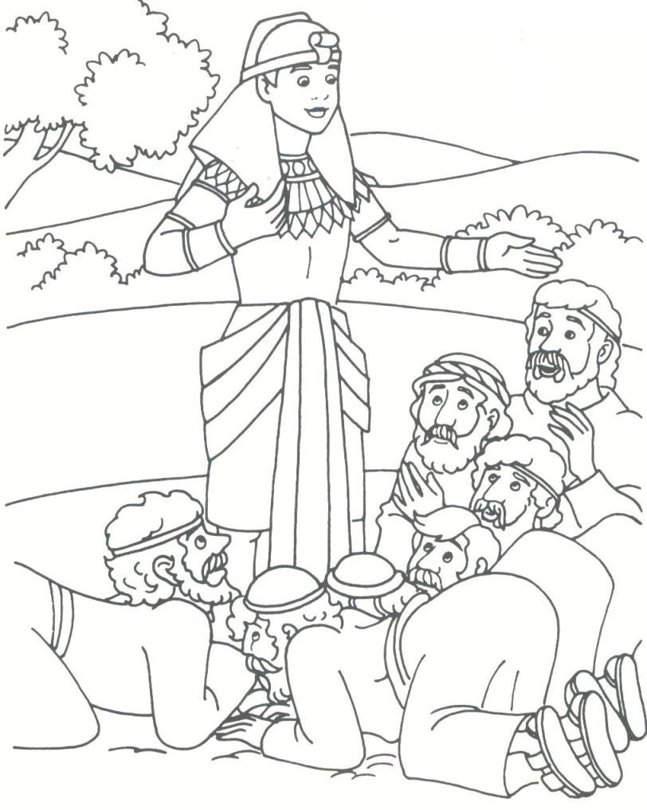
3 | THE LIFE OF JACOB’S SONS
 | Joseph flees from sin

Genesis 39: 1–23

The story so far…

Judah’s life was far from perfect; this is not what would be expected from someone in the royal family line. He married a Canaanite woman, contrary to God’s clear instructions to his ancestors; he then engaged in an immoral sexual relationship with his daughter-in-law, Tamar, without even knowing it was her, providentially giving birth to Perez who would be in the royal lineage of both great kings, David and Jesus; and he failed to keep his promise to Tamar, after her husband’s death, to give her his youngest son to continue his dead eldest son’s family line. And this family line was rather important; for from his line was to come the promised descendant, Jesus, who would reverse the effects of sin.

Yet despite his waywardness, God is still at work behind the scenes, orchestrating the fulfilment of His promise through good and bad alike, showing He is sovereign and that He will fulfil His promise (12:1-3).

Joseph is now a slave in a high-ranking Egyptian official’s home. And there could not be a starker contrast between Judah and Joseph regarding sexual morals.

The story unfolds…

- While Joseph is owned by Potiphar as a slave, what evidence is there that God is still at work in his life – even in a foreign land (1)? Coincidence?

Joseph’s slavery in Egypt foreshadows the slavery that the ever-growing number of Abraham’s descendants would experience in Egypt; this once more potentially presents a setback to God fulfilling His promise.
- Why is Joseph prosperous in his every endeavour in Egypt (2)?

- What does Potiphar recognize about Joseph (3-4)?

- What’s the significance of an Egyptian household prospering because of Joseph’s service as a slave therein (5-6)?

- Potiphar’s wife notices Joseph’s sexual appeal and makes advances (6-10).

  - How does Joseph deal with the temptation from his master’s wife?

  - Why does he resist this temptation?

- How does Joseph deal with her irresistible sexual seduction (11-12)?

- Potiphar’s wife then frames innocent Joseph as a vulnerable Hebrew slave living in a foreign land (13-18). Compare Potiphar’s response to Joseph (19) with Judah’s response to news of Tamar’s pregnancy (38:24).

  - What similarities exist?

  - What differences are there?

Joseph is innocent; he epitomizes righteousness – a desire to live a life of purity in devotion to God. However, he is unjustly imprisoned. This has been a rather rough ride – from the waterless pit and sold into slavery to prosperity and prison!

- What signs are there once again to show that God is still at work and that He will yet use Joseph while in prison for a significant purpose (20-23)?

Towards its fulfilment…

How does this episode show the fulfillment of God’s promises regarding:

- The promised land?

- The promised descendants?

- The promised blessing?

- God’s promised rule?

